Experiment No. 8

**To perform nested queries from multiple tables.**

[**Content**](https://www.camu.in/lms#tab-1)[**Conversations**](https://www.camu.in/lms#tab-2)

**To perform nested queries from multiple tables**

**Nested Queries**

A nested query is a query that has another query embedded within it. The embedded query is called a subquery. A subquery typically appears within the WHERE clause of a query. It can sometimes appear in the FROM clause or HAVING clause.

[**SQL_42]** SQL> SELECT * FROM faculty;

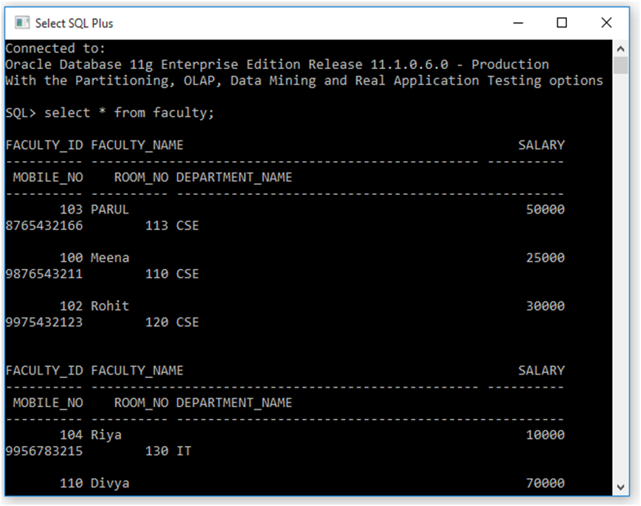

[**SQL_43]** SQL> SELECT faculty_name, department_name

FROM faculty WHERE salary= (SELECT salary FROM faculty WHERE faculty_id=104);

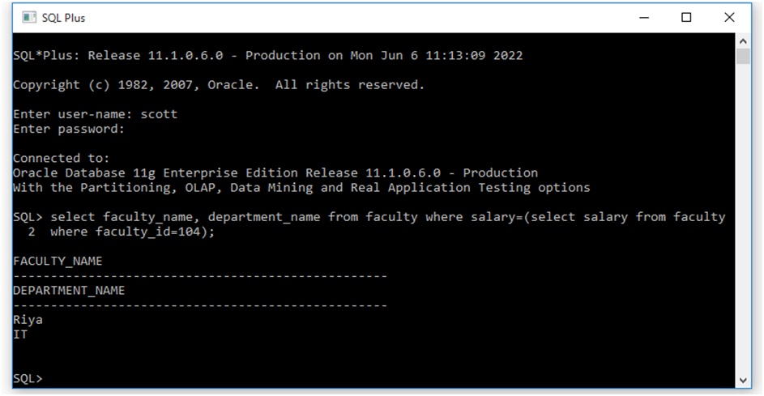

[**SQL_44]** SQL> SELECT faculty_name, department_name, mobile_no

FROM faculty WHERE salary > (SELECT salary FROM faculty WHERE faculty_id=102);

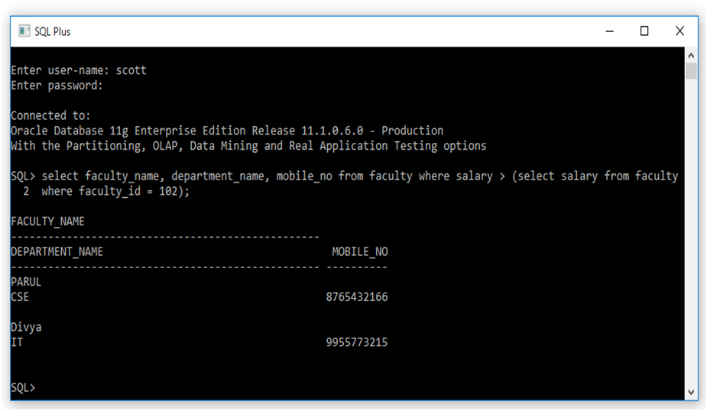

[**SQL_45]** SQL> SELECT faculty_name, department_name

FROM faculty WHERE salary = (SELECT max(salary) FROM faculty);

**[SQL_46]** SQL> SELECT faculty_name, department_name

FROM faculty WHERE salary = (SELECT min(salary) FROM faculty);

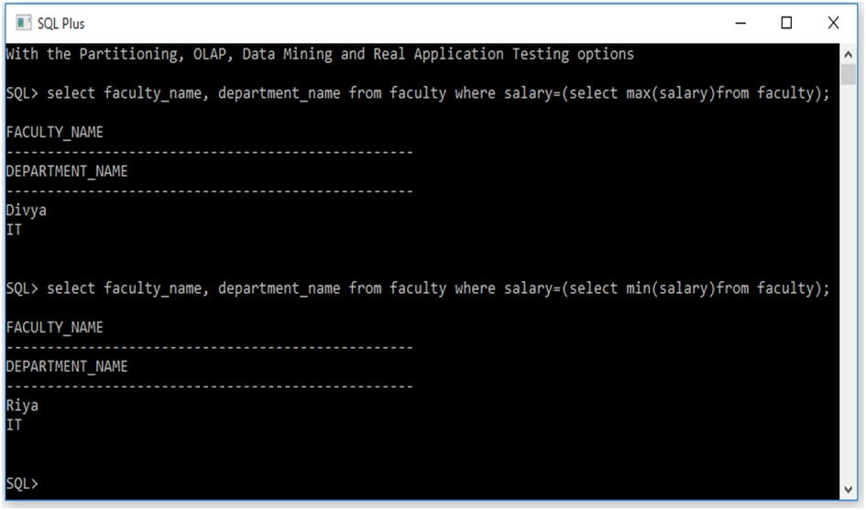

**[SQL_47]** SQL> SELECT stud_name, rollno, dob FROM student WHERE department_name <> (SELECT      department_name FROM student WHERE stud_id=’A002’);

